
An invitation for Exchange Students Program in Spring 2021
to Zhongkai University of Agriculture and Engineering
Based on the agreement between Zhongkai University of Agriculture and Engineering (ZHKU) and Chungbuk National University (CBNU), we warmly welcome students from CBNU to our university in the spring of 2021. More detailed information is as follows:
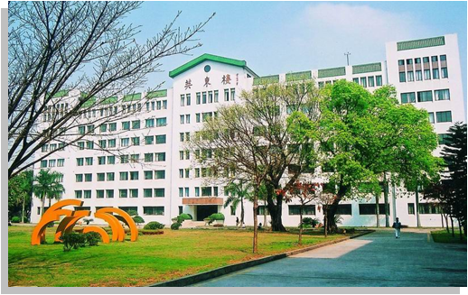
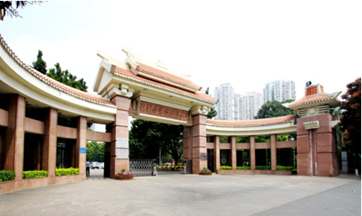
- About ZHKU
ZHKU is a public provincial comprehensive university with the dominant disciplines in agriculture, engineering and management, and offers bachelor’s and master’s in the fields of agriculture, engineering, science, economics, management, social sciences, fine arts and law. The university has 1327 faculty members and a total enrollment of over 23000 students. It has 1 postdoctoral research workstation, 9 first-level disciplines of master's degree and 58 programs of bachelor’s degree.
The school is located in Guangzhou, a famous cultural metropolis with a history of more than two thousand years in southern China. There are two campuses, respectively in Haizhu and Baiyun, with a total area of more than 300 acres. Haizhu campus is located in the downtown city by the Pearl River, with superior cultural environment and convenient transportation, which is less than 2 kilometers from Beijing Road, Jiangnanxi Street and other commercial and business centers. Baiyun campus is located in the second university town in Baiyun District, Guangzhou. The campus has excellent surroundings with mountains and river passing through, which creates a natural and ecological environment for students’ leaning and living.
Through diversified teaching, research and cultural activities, our university strives to cultivate high-level talents with practical ability and innovative ideas. In recent years, ZHKU students participate in a variety of high-level practical skill competitions at or above the provincial level, and our students win hundreds of awards every year. For example, for many years in a row the students participate in Chinese college students mathematical modeling competition, and American college students mathematical modeling competition, winning the national first prize or international first prize. For example, students won the first prizes of state level and international level in Contemporary Undergraduate Mathematical Contest in Modeling, and Mathematical Contest In Modeling, which ranked as one the tops in Chinese universities of the same level. For successive three years, there are works of ZHKU teachers and students showed in Guangzhou International Lighting Festival. The students also achieved good results in the National Software and Information Technology Professional Competition, National three-dimensional Digital Design Competition, China College students Innovation and Entrepreneurship Competition (PMC), China Educational Robot Competition, National College Students English Competition, College Students Entrepreneurship Competition, and National College Students Advertising Art Competition.
ZHKU and CBNU have established a good educational exchange relationship since 2016, and the two universities have sent a number of students to carry out exchanges program for one semester or one academic year. Students from CBNU are warmly welcomed to our university.
The university has 17 teaching colleges and 58 majors, which offer courses for overseas students. Most of the courses are taught in Chinese, and courses for English and business English majors are taught in both Chinese and English (more details can be consulted http://zsb.zhku.edu.cn/class.aspx?id=4). Exchange students can also choose Chinese and Chinese cultural courses (more details about the courses in attachment1).
Ⅱ.Exchange Students Program
1. Time of exchange: February 25, 2019 to mid-July, 2021.
2. Academics during exchange:
All courses offered are open for overseas students. The students participating in the program join in the class of ZHKU students. After exchange, the students can obtain a certificate and transcript offered by ZHKU.
Courses open for Chinese majors of CBNU are shown in attachment 1, and the courses may be slightly adjusted by January, 2021.
3. Number of exchange students and the cost:
Number of students with free tuition: 10 students per semester, or equivalent number of ZHKU students to CBNU;
Number of students with tuition: unlimited, 12000 RMB for one semester;
Accommodation: it depends, 3000 RMB ~ 12000 RMB per person.
4. Requirements:
(1) with no record of crime or university punishment;
(2) with positive learning attitude, required credits in CBNU and good grade;
(3) with no asthma, heart disease, infectious disease and other diseases;
(4) having a high level of Chinese or English, with HSK 2 or above, adapting to the bilingual teaching in Chinese and English, or Chinese and Japanese.
Ⅲ.Application time and requirements
1.Documents for application:
(1) a sealed transcript from CBNU in Chinese or English,
(2) proof material of Chinese proficiency (photocopy);
(3) application form (see attachment 2, or a form provided by CBNU with the required information).
2. Deadline
All the scanned copies of the documents should be sent to international@zhku.edu.cn, by October 31st .
3. Warm tips
Though the coronavirus epidemic has waned in China and Korea, the global situation is still severe. China-Korea Entry-Exit Policy, measures of epidemic prevention and the teaching arrangements of our university in 2021 will adjust moderately. The latest requirements for Korean citizens to come to work or study in China can be found in this website:
https://mp.weixin.qq.com/s/Z5Vnej91aV1aTASw4c3w8w.
Please closely watch the policy and notice issued by China-South Korea Entry-Exit Administration and Chinese Embassy in South Korea. The fees related to test, quarantine, prevention and control, and other unforeseen expenses before and after entering China should be paid by the students themselves.

Foreign Affairs Office
International Education Office
September 15, 2020

Attachment 1

中文（汉语）专业春季可选课程
Courses Offered for Chinese majors from CBNU in the spring semester

Courses  (课程名称) | Teaching units（开课单位） | Academic hours（theoretical 理论/实验 experimenting） | credit
大学语文  College Chinese | College of Humanity and Social Science人文与社会科学学院 | 24 hours | 1.5
普通话训练  Practice in Mandarin | College of Humanity and Social Science人文与社会科学学院 | 24 hours | 1.5
中国文化概论Understanding Chinese Culture | College of Humanity and Social Science人文与社会科学学院 | 24 hours | 1.5
演讲与口才  Speech and Eloquence | College of Humanity and Social Science人文与社会科学学院 | 24 hours | 1.5
口才与辩论  Eloquence and Debate | College of Humanity and Social Science人文与社会科学学院 | 24 hours | 1.5
办公软件应用  Office Software Application | College of Humanity and Social Science人文与社会科学学院 | 16 hours | 1
办公软件技能大赛  Competition of Office Software Skills | College of Humanity and Social Science人文与社会科学学院 | One week | 1
社会调查理论与方法  Theory and Solution of Social Investigation | College of Humanity and Social Science人文与社会科学学院 | 40 | 2.5
文献检索与论文写作  Literature Retrieval and Essay Writing | College of Humanity and Social Science人文与社会科学学院 | 16 hours | 1
民俗学  Folklore | College of Humanity and Social Science人文与社会科学学院 | 32 hours | 2
广东文化地理  Guangdong Cultural Geography | College of Humanity and Social Science人文与社会科学学院 | 32 hours | 2
文化市场营销学  Cultural Marketing | College of Humanity and Social Science人文与社会科学学院 | 32 hours | 2
美学原理  Aesthetic Ideology | College of Humanity and Social Science人文与社会科学学院 | 16 hours | 1
世界饮食文化  International Dietary Culture | College of Food Science and Technology食品科学与工程学院 | 16 hours | 1
基础韩国语  Basic Korean | College of Food Science and Technology食品科学与工程学院 | 16 hours | 1
合计Total |  |  | 22

Attachment 2
Application Form for Studying Abroad in ZHKU
国 籍  Nationality |  | 所在学校  SendingUniversity | CBNU
姓 名  Name |  | 性 别  Sex
出生日期  Date of Birth | Y M D | 联系电话/邮箱  Tel/Email:
所在学院（系）  专业班级  Major/Year in CBNU |  | 学号/护照号  Student ID/ Passport Number
申请交流专业及类别  Desired Major / Program |  | 申请交流时间  Exchange Period | Y M D TO  Y M D
平均学分绩点/专业年级排名  GPA/Academic Ranking | / |  | 汉语（英语）能力成绩和等级（附证书复印件）  Chinese (English) Language proficiency
拟选修课程
Courses to take in ZHKU
自荐说明  Self-Recommend | Signature：  Y M D
学校意见  Approval from the sending university | Signature：  Director of International Office（seal）  Y M D
备注：请双面打印，签字笔或钢笔签名。Notes: Please print in double-side and Sign with pen.

