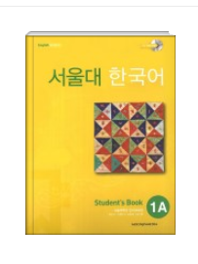
Student’s Book
\18,000
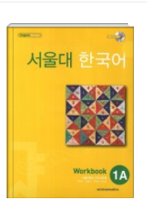
Workbook
\12,000

TOTAL: \30,000

